**ABES ENGINEERING COLLEGE, GHAZIABAD**

**DEPARTMENT OF ELECTRONICS & COMMUNICATION ENGINEERING**

**FUNDAMENTALS OF ELECTRONICS ENGINEERING [BEC-101/201]**

**ASSIGNMENT SHEET_DIGITAL ELECTRONICS**

1. **Convert the following to the corresponding bases:**
2. (73.12)10 = ( )2
3. (110110.011)2 = ( )16
4. (231.36)10 = ( )2
5. (11011.10) 2= ( )10
6. (6FB.67)16 = ( )10
7. **Convert the following to the corresponding bases:**
8. (437)8= ( )10
9. (1110111.11011)2 = ( )8
10. (1011.10110)2 = ( )16
11. (743.15)8 = ( )2
12. (9AC.1B)16= ( )2
13. **Simplify the following logic expression using Boolean Algebra:**
14. F= (A+C) (AD+A $\overline{D}$)+AC+C
15. F= ((A.B)’ + C)’. B
16. Y = $\overline{\left(\overline{(A+\overline{B}}\right)+\left(\overline{(A.\overline{B}}\right)+(\overline{\overline{A}.B})}$
17. Y = $\overline{A}B (\overline{D}$ + $\overline{C}$ D) +B (A+ $\overline{A}$ CD)
18. Y = $\overline{\overline{A\overline{B}+ABC}+A(B+A\overline{B})}$
19. **Consider the following Boolean expression:**
20. F (A, B, C) = A+B $\overline{C}$ + $\overline{A}$ BC, convert it into standard SOP form
21. F (A, B, C) = A.( $\overline{B}$ + $\overline{C}$). (A+ $\overline{B}$ + $\overline{C}$), convert it into standard POS form
22. F (A, B, C) = (A+ $\overline{B}$). (B+C), convert it into standard POS form
23. **Simplify the expression using K-Map and implement using NAND logic gates.**
24. F(A, B, C, D, E)=∑m(0,1,2,4,5,6,10,13,14,18,21,22,24,26,29,30
25. F (A, B, C, D, E) = ∑m (0,2,5,7,8,10,16,21,23,24,27,31)
26. F (A, B, C, D) = Σ m (3,5,9,11,15) + d (2,4,6,10)
27. Y = $\prod{M}$ (4,6,10,12,13,15)
28. Y = $\prod{M}$ (0,1,2,3,7,8,10) + d (5,6,11,15)
29. **Simplify the expression using K-Map and implement using NOR logic gates.**
30. F (A, B, C, D, E) = Σm (1,3,4,5,6,7,9,11,13,15)
31. F (A, B, C, D, E) = $\overline{A}\overline{ B} \overline{C}+A \overline{C} \overline{D}+A \overline{B}+ABC\overline{D}+\overline{A} \overline{B} C$
32. F (A, B, C, D) = AB’C’ +A’BC + A’B’CD +ABCD + d (1,5)
33. **Perform the following:**
34. (4433)5 = (?)10= (?)2
35. (5654)7 = (?)2
36. (292)10 = (1204)x. Find the value of x.
37. (1001.10101)2 = (?)Gray
38. (1010111.01010111)Gray = (?)2
39. **Perform the following:**
40. (101010101.1101010)2 = (?)1’s complement
41. (1101010101111.0101011)2= (?)2’s complement
42. (123.54533)6 = (?)10 = (?)2= (?)8
43. (3132.5)8 = (?)16

**9. Derive a logic expression for a four input digital system, the output of which equals to 1 only when there are odd number of ones in the input combinations. Draw the logic diagram and construct the truth table.**

**10. Simplify using K map:**

**i.** F (A,B,C,D,E,F) = $\sum{m(0,4,8,9,12,13,16,20,24,25,28,29,32,36,40,41,44,45,48,52,56,57,60,61)}$

ii. F (A, B, C, D, E) = $\sum{m(0,4,8,12,16,20,22)}$ + d (24,26,30,31)

**11**. **Consider X = 1010100; Y = 1000011: Perform using 2’s complement & 1’s complement methods separately:** i. X – Y ii. Y-X

**12.Why are NAND and NOR gates called Universal Logic Gates? Implement the following using NAND and NOR gates:**

1. NOT ii. AND iii. OR iv. EXOR v. EXNOR vi. NOR

**13**. **Q15. Verify the truth table of a 3 input EXOR gate.**

**14. Design a logic circuit having three inputs X, Y and Z. The output is 1 only when Y=Z = 1.**

**15. Using 10’s complement & 9’s complement method, perform:**

1. 76532 – 4250 ii, 4250 – 76532

**Q16. Evaluate the output of the given circuit when A = 0, B = 0 , C= 1 and D = 1.**

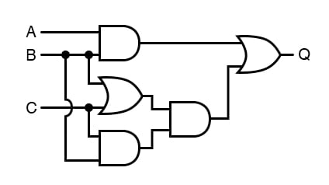

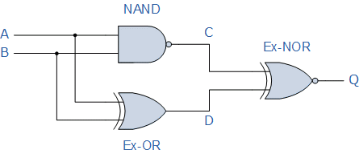

**Q17. Find the complement of F = x + yz. Show that F.F’ = 0 and F + F’ = 1.**

**Q18. Use the K-map method to implement the logic function specified in the following truth table, both in SOP as well as POS form.**

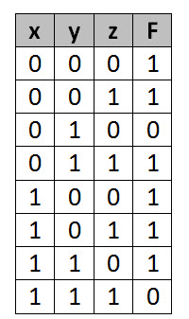

**19. Simplify the Boolean function using don’t care conditions in POS form:**

F = $\overline{B }\overline{C}$ $\overline{D}$ + BC $\overline{D}$ + ABC $\overline{D}$; d = $\overline{B}$ C $\overline{D}$ + $\overline{A}$ B $\overline{C}$ D

**20. Obtain the standard SOP and standard POS expression for the logic function whose truth table is given below:**

XXXXXXXXXXXXXXXXXXXXXXXXXXXXXXXXXXXXXXXXXXXXXXXXXXXXXXXX